

Sprint 1 Proposal: Hospital Management System

Programme: MSc Computing
Module Title: SOFTWARE DEVELOPMENT 2

Team Details

Full Name | ID No:
Tharun Kumar | A00085282
Sai Krishna | A00083489
Mani | A00049148
Akhilesh | A00085933
Mohan | A00037737

Table of Contents

1. Introduction 3
2. Project Overview 3
3. Purpose and Objectives 3
3.1 Personas 4
4. Technology Stack 5
5. Front-End Development 5
5.1 List of Functionalities 5
5.2 Front-End Communication 5
6. Back-End Development 5
6.1 Responsibilities 6
6.2 Architecture Benefits 6
7. Database, Version Control and Deployment 6
7.1 Database (MySQL) 6
7.2 Version Control (Git) 6
7.3 Deployment (Docker) 6
8. Allocation of work 7
9. Project Plan 7
10. Conclusion 8
11. Appendix 8

1. Introduction
Hospitals require highly efficient systems to manage a variety of critical operations, including patient registration, appointment scheduling, staff management, medical record keeping, and billing. Traditional manual processes often result in delays, human errors, redundant paperwork, and overall inefficiencies, which can compromise patient care and staff productivity. To address these challenges, this proposal presents the development of a Hospital Management System (HMS) as a web application. The system will leverage React.js for the front-end to provide a responsive and intuitive user interface, Node.js and Express.js for the back-end to handle server-side operations and APIs efficiently, and MySQL for reliable database storage of sensitive patient and hospital data. Furthermore, Git will be employed for version control to ensure collaborative development and maintain a history of changes, while Docker will facilitate consistent deployment across different environments. By adopting these modern technologies taught in the module, the development team can ensure a structured, scalable, and maintainable system while allowing all members to contribute effectively.

2. Project Overview
The proposed HMS will serve as a centralised platform to streamline hospital operations. It will manage patient records, staff details, appointment schedules, medical histories, and billing processes in an integrated manner. The system will support multiple user roles, including administrators, doctors, receptionists, and patients, each having secure, role-based access to relevant features. Administrators can oversee the overall hospital operations, manage staff, and monitor system activity. Doctors can access patient histories, update medical records, and manage appointments. Receptionists can handle patient registration, appointment scheduling, and billing tasks. Patients can book appointments, view medical records, and track billing details. The web-based nature of the HMS ensures cross-device accessibility, while a responsive interface guarantees usability across desktops, tablets, and mobile devices. Overall, the HMS aims to improve hospital efficiency, minimise errors, enhance patient care, and provide a seamless experience for staff and patients alike.

3. Purpose and Objectives
The purpose of the HMS is to improve operational efficiency and data accuracy in hospitals. Objectives include:
- Digitalising patient and staff management
- Streamlining appointment scheduling
- Improving accessibility and reliability of patient information
- Reducing administrative workload
- Ensuring secure handling of sensitive healthcare data
- Applying modern web development practices

3.1 Personas
Persona 1: Dr. Ananya Rao
- Age: 35
- Role: Doctor
- Background: Senior physician at a busy hospital, experienced in patient care and medical records. Uses computers for patient history and diagnosis but prefers simple, intuitive systems.
- Goals:
  - Access patient medical records quickly.
  - Manage appointments efficiently.
  - Ensure accurate billing and prescriptions.
- Frustrations:
  - Complex or slow hospital management systems.
  - Difficulty in accessing patient history quickly.
- Technology Comfort: Moderate – comfortable with web-based applications but prefers clear navigation.

Persona 2: Ankith Sharma
- Age: 28
- Role: Patient
- Background: Working professional, visits the hospital occasionally for check-ups. Uses mobile and web apps regularly for appointments and health tracking.
- Goals:
  - Book appointments online without waiting.
  - Access personal medical records easily.
  - Pay bills online and track prescriptions.
- Frustrations:
  - Long queues at hospital reception.
  - Confusing appointment booking systems.
- Technology Comfort: High – comfortable using apps and online services.

4. Technology Stack
- Front-End: React.js
- Back-End: Node.js with Express.js
- Database: MySQL
- Version Control: Git
- Deployment: Docker
This stack ensures scalability, modularity, and compliance with module requirements.

5. Front-End Development
The front-end of the Hospital Management System (HMS) will be developed using React.js, a component-based JavaScript library that enables the creation of interactive and dynamic user interfaces. React’s modular structure allows developers to build reusable components, making the system scalable, maintainable, and efficient. This approach ensures that the HMS can deliver a consistent user experience across different sections of the application while facilitating collaboration among team members.

5.1 List of Functionalities
- Responsive dashboards for administrators, doctors and patients
- Forms for patient registration and appointment booking
- Add, update, and manage medical records and prescriptions
- Schedule, reschedule, and cancel appointments
- Generate billing records and manage payments

5.2 Front-End Communication
React will interact with the back-end using RESTful APIs, allowing seamless data retrieval and updates. This integration ensures that user actions on the front-end are immediately reflected in the back-end database, maintaining data consistency and providing a smooth, responsive user experience. Overall, React.js will serve as the foundation for a user-friendly and interactive HMS interface, improving efficiency and accessibility for all users.

6. Back-End Development
The back-end of the Hospital Management System (HMS) will be developed using Node.js and Express.js, providing a robust environment for handling server-side logic, routing, and database interactions. Node.js offers an event-driven, non-blocking architecture, making it ideal for building scalable and high-performance applications. Express.js, as a lightweight web framework, simplifies the creation of APIs, routing, and middleware integration, ensuring a clean and maintainable codebase.

6.1 Responsibilities
- Managing RESTful API endpoints
- Implementing authentication and authorization
- Connecting to the MySQL database
- Processing client requests and sending JSON responses

6.2 Architecture Benefits
This back-end architecture ensures secure, efficient, and reliable communication between the front-end and database. It enables scalable management of concurrent requests, reduces response time, and maintains data integrity. Overall, using Node.js and Express.js establishes a strong foundation for a responsive, maintainable, and secure HMS capable of supporting multiple user roles and hospital operations seamlessly.

7. Database, Version Control and Deployment

7.1 Database (MySQL)
The Hospital Management System (HMS) will utilize MySQL as the primary database for persistent storage. The database will include structured tables such as Users, Patients, Doctors, Appointments, MedicalRecords, and Billing. This relational design ensures data integrity, minimizes redundancy, and allows efficient querying of complex relationships, such as retrieving patient medical histories or generating billing summaries. By maintaining normalized tables and enforcing constraints, the system guarantees accurate and consistent data management across all hospital operations.

7.2 Version Control (Git)
Git and GitHub will be used for version control, enabling collaborative development among team members. The workflow will involve feature-based branches, regular commits, and pull requests to track changes, facilitate code reviews, and maintain a clear history of project progress. This approach ensures accountability, reduces conflicts, and allows seamless integration of new features while maintaining code quality.

7.3 Deployment (Docker)
Docker will be employed to containerize the front-end, back-end, and database components. Containerization ensures consistent environments across development, testing, and production, simplifying deployment and reducing environment-related issues. Additionally, Docker facilitates scalability, allowing the HMS to handle increasing user loads efficiently. Overall, the combination of MySQL, Git, and Docker provides a robust, reliable, and maintainable infrastructure for the HMS.

8. Allocation of work
- Tharun Kumar – Front-End Development: Tharun is responsible for designing and implementing the user interface using React.js. This includes creating responsive dashboards, building forms for patient registration and appointment booking, and developing tables and cards for displaying medical records and billing. He will also manage dynamic interactions using React’s state and props to ensure a smooth and interactive experience.
- Sai Krishna – Back-End Development: Sai Krishna will handle the server-side logic using Node.js and Express.js. His responsibilities include creating RESTful API endpoints, implementing authentication and authorization, processing client requests, and maintaining secure communication with the MySQL database to ensure reliability and efficiency.
- Mani – Database Management: Mani will manage MySQL database design, including creating tables for Users, Patients, Doctors, Appointments, MedicalRecords, and Billing. He will enforce relational integrity and ensure efficient querying, supporting smooth data access for all system users.
- Akhilesh – Version Control: Akhilesh will oversee Git and GitHub version control, managing feature branches, commits, and pull requests. He will ensure effective collaboration among team members and maintain a clear history of project changes.
- Mohan – Deployment & Integration: Mohan will be responsible for deployment using Docker, containerizing the front-end, back-end, and database. He will also assist with integration and testing, ensuring consistent environments, scalability, and seamless communication between all system components.

9. Project Plan
The project will follow an iterative development plan spanning requirement analysis, design, implementation, testing, and deployment. Key milestones include front-end and back-end module completion, database integration, RESTful API testing, user acceptance testing, and final deployment using Docker. Tasks will be tracked via a Gantt chart, ensuring timely completion and addressing dependencies efficiently.
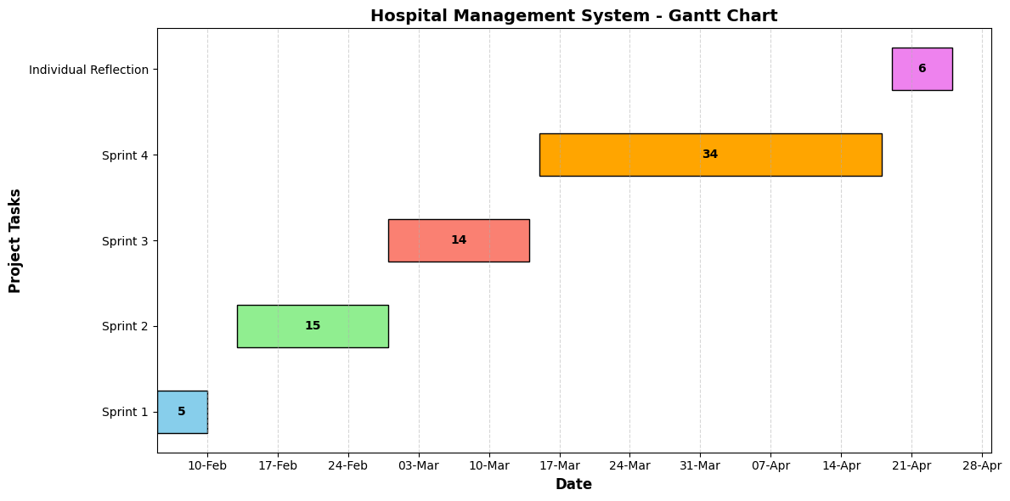

10. Conclusion
The Hospital Management System aims to streamline hospital operations, providing a secure, efficient, and user-friendly platform for patients, doctors, administrators, and receptionists. By integrating modern technologies like React.js, Node.js, MySQL, Git, and Docker, the system ensures reliable performance, scalability, and maintainability. The proposed allocation of work and structured project plan guarantees timely development while fostering effective team collaboration, ultimately enhancing hospital efficiency and patient care.

11. Appendix

Git Hub Link
https://github.com/Tharunkumar0412/GROUP-PROJECT---HOSPITAL-MANAGEMENT-SYSTEM

Kanban Board / Task board Link
https://app.clickup.com/90152351755/v/b/6-901520945601-2

Code of Conduct
All team members of the Hospital Management System project, including Tharun Kumar, Sai Krishna, Mani, Akhilesh, and Mohan, agree to work professionally, responsibly, and respectfully. Each member will communicate clearly, meet deadlines, and maintain the quality of their work. Teamwork and collaboration are expected, including sharing knowledge, helping each other, and resolving conflicts politely. All members will act with honesty and integrity, avoiding plagiarism or any unethical behaviour. Project resources, including code, tools, and data, will be used responsibly, and sensitive information will be kept secure. Any concerns or issues will be reported to the team lead and handled fairly and promptly. By following this Code of Conduct, all members commit to contributing positively to the success of the project and ensuring a respectful, ethical, and productive working environment.

Full Name | ID No:
Tharun Kumar | A00085282
Sai Krishna | A00083489
Mani | A00049148
Akhilesh | A00085933
Mohan | A00037737

